**WEEK 6 HandsOn**

**HandsOn Task 4 :**

**Task :**

* Implement componentDidMount() hook
* Implementing componentDidCatch() life cycle hook.

**CODES AND OUTPUTS :**

1. **Create a new react application using *create-react-app* tool with the name as “blogapp”**

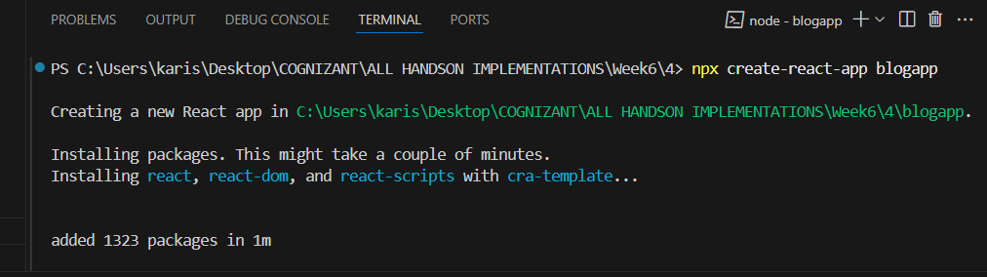

cd blogapp > npm start

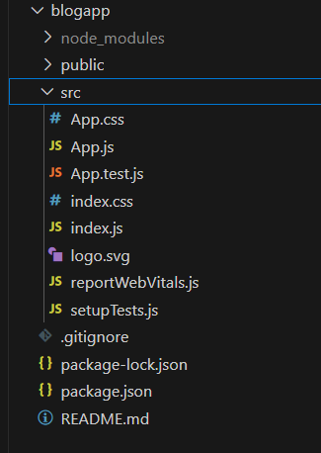

1. **Create a new file named as Post.js in src folder**

Post.js :

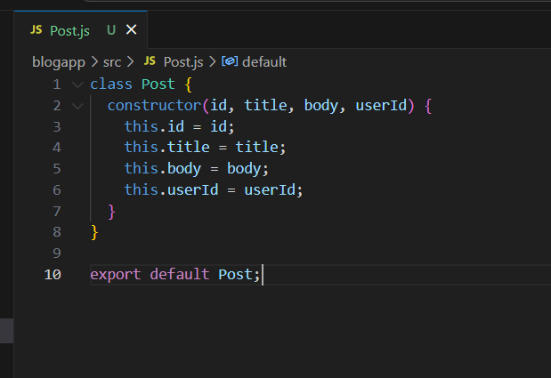

class Post {

  constructor(id, title, body, userId) {

    this.id = id;

    this.title = title;

    this.body = body;

    this.userId = userId;

  }

}

export default Post;

**3 . Create a new class based component named as Posts inside Posts.js file**

class Posts extends Component {

  constructor(props) {

    super(props);

    this.state = {

      posts: []

    };

  }

**Posts Components :**

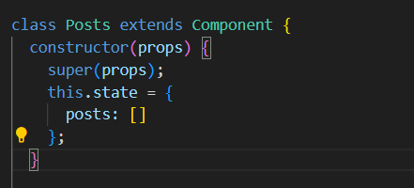

**4 . Initialize the component with a list of Post in state of the component using the constructor**

**Create a new method in component with the name as loadPosts() which will be responsible for using Fetch API and assign it to the component state created earlier. To get the posts use the url (**[**https://jsonplaceholder.typicode.com/posts**](https://jsonplaceholder.typicode.com/posts)**)**

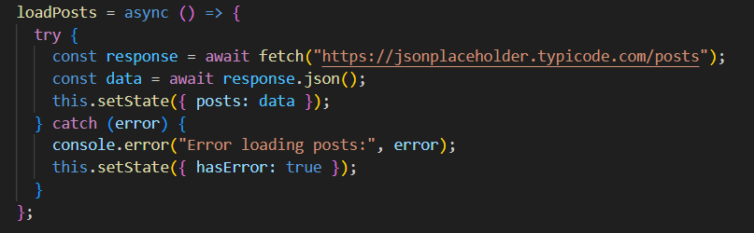

**loadPosts method :**

 loadPosts = async () => {

    try {

      const response = await fetch("https://jsonplaceholder.typicode.com/posts");

      const data = await response.json();

      this.setState({ posts: data });

    } catch (error) {

      console.error("Error loading posts:", error);

      this.setState({ hasError: true });

    }

  };

1. **Implement the render() which will display the title and post of posts in html page using heading and paragraphs respectively.**

**Render() to display title and posts :**

 render() {

    return (

      <div>

        <h2>Posts</h2>

        {this.state.posts.map((post) => (

          <Post key={post.id} title={post.title} body={post.body} />

        ))}

      </div>

    );

  }

}

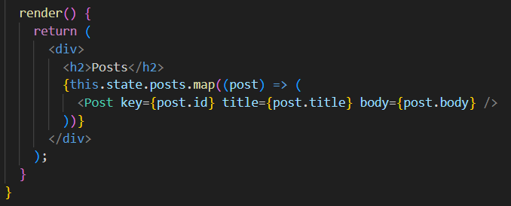

**6 . Define a componentDidCatch() method which will be responsible for displaying any error happing in the component as alert messages.**

**componentDidCatch( ) :**

 componentDidCatch(error, info) {

    console.error("Error caught in component:", error, info);

    alert("An error occurred while rendering posts!");

  }

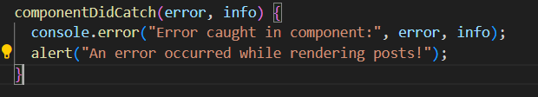

**7 . Add the Posts component to App component.**

**src/ App.js :**

import React from "react";

import "./App.css";

import Posts from "./Posts";

function App() {

  return (

    <div className="App">

      <h1>Blog App</h1>

      <Posts />

    </div>

  );

}

export default App;

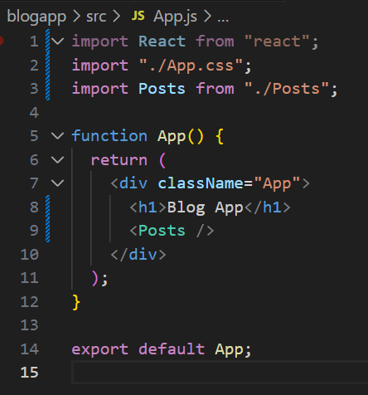

**8 . Build and Run the application using *npm start* command.**

**Output :**

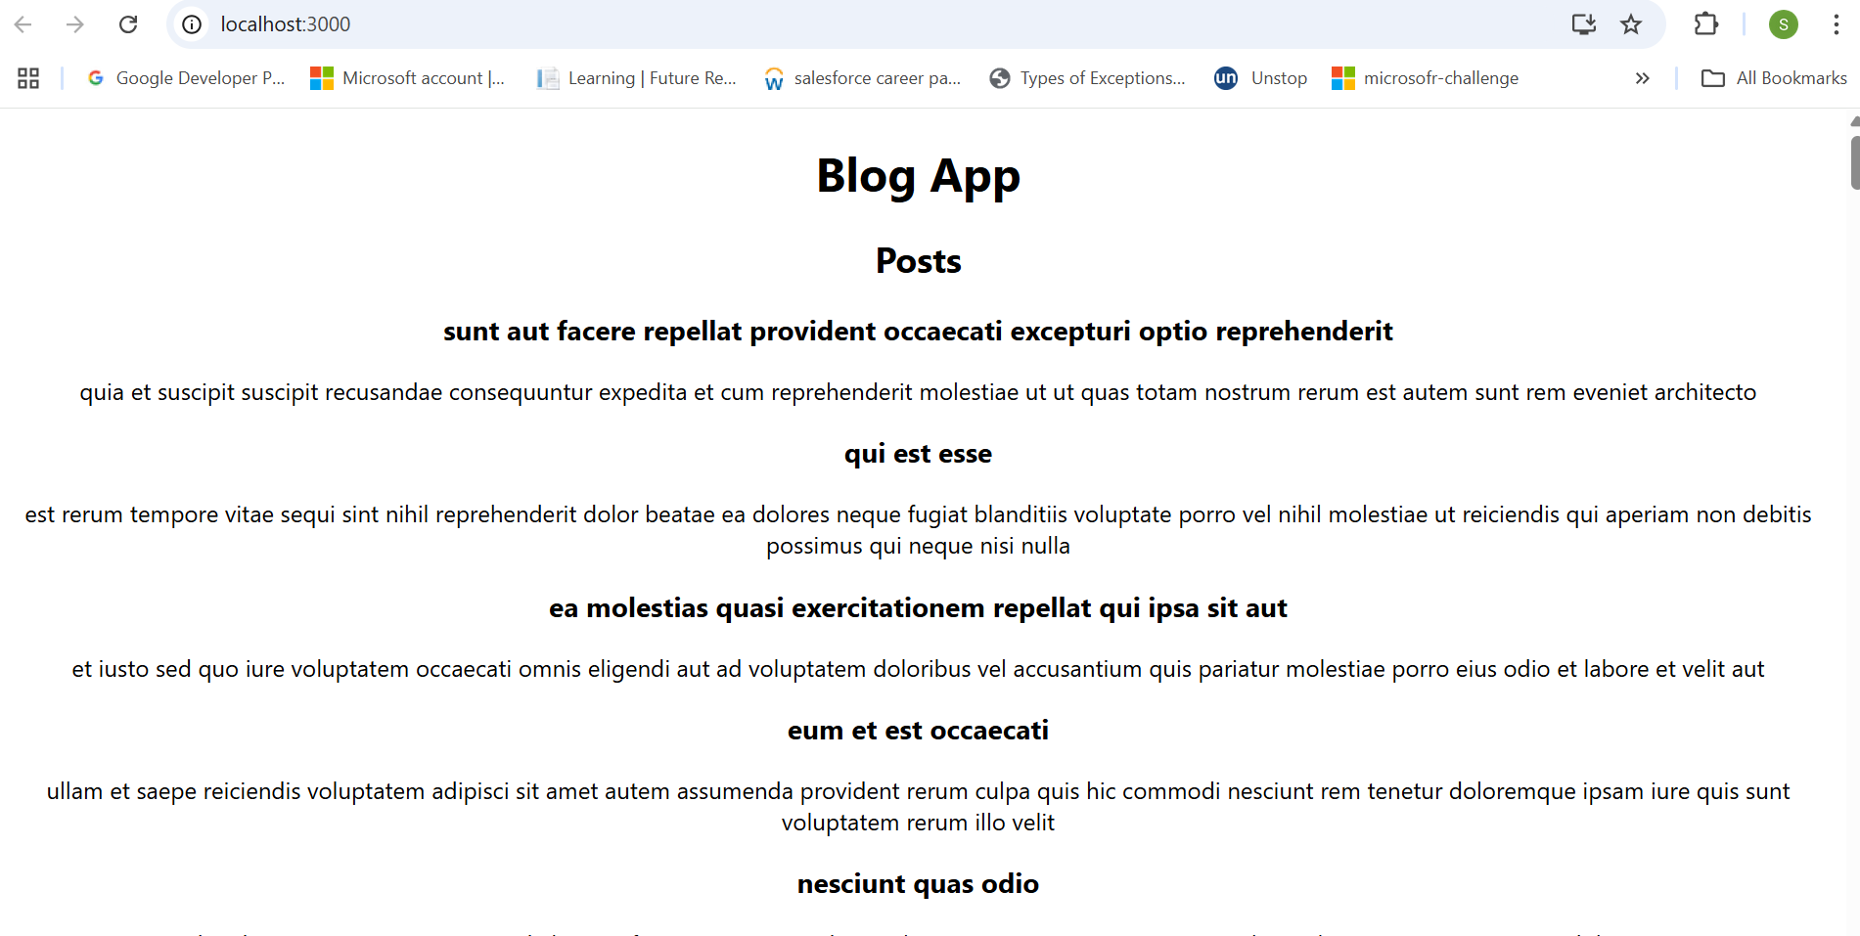

**Done with week6 Handson task 4 .**